# 

# E-Products Recommendation System Based on User’s Rating.

Md. Nasim Hossain and Asmany Akter

A Thesis in the Partial Fulfillment of the Requirements

for the Award of Bachelor of Computer Science and Engineering (BCSE)



Department of Computer Science and Engineering

College of Engineering and Technology

IUBAT – International University of Business Agriculture and Technology

Spring 2021

E-Product Recommendation System Based on User’s Rating

Md. Nasim Hossain and Asmany Akter

A Thesis in the Partial Fulfillment of the Requirements for the Award of Bachelor of Computer Science and Engineering (BCSE)

The thesis has been examined and approved,

_____________________________

Prof. Dr. Md. Abdul Haque

Chairman and Professor

Dept. of Computer Science and Engineering

_____________________________

Prof. Dr. Utpal Kanti Das

Coordinator and Professor

_____________________________

Md.Sakibul Islam

Supervisor

Department of Computer Science and Engineering

College of Engineering and Technology

IUBAT – International University of Business Agriculture and Technology

Spring 2021

## **Abstract**

The E-Commerce Industry is rapidly emerging all over the world. E-commerce site provides the independence to choose and buy things over the internet. However, Different websites put different prices on the exact same product and this leads people to spend extra money on products which could be bought with less. Another there are several e-commerce site available in Bangladesh. One Price Comparison tool is developed “Upoma – A Dynamic Price Comparison Tool for Bangladeshi E-Commerce Websites”. But they are not working with the user’s rating. Hence, we develop a Price Recommendation System based on the user’s rating. We have fetched over 50,000 products details from various websites to enrich our result based on the user’s query. After that we store this data to a csv file. Our System recommend the top 10 products details which rating is good. Our system displays the result with 92% Accuracy according to the user’s query.

## **Letter of Transmittal**

6 February 2021

The Chair

Thesis Defense Committee

Department of Computer Science and Engineering

IUBAT– International University of Business Agriculture and Technology

4 Embankment Drive Road, Sector 10, Uttara Model Town

Dhaka 1230, Bangladesh

**Subject:** Letter of Transmittal.

Dear Sir,

We are pleased to present to you our thesis report titled “E-Products Price recommendation System Based on user’s rating”.

As required by IUBAT for the partial fulfilment of the requirements for the award of Bachelor of Computer Science and Engineering. It was indeed a great opportunity for us to work on this project to actualize our theoretical knowledge into practice. Now we are looking forward for your kind appraisal of our report.

Finally, we would like to thank you for giving us the opportunity to pursue our studies in your renowned university.

Yours sincerely,

_____________

Md. Nasim Hossain and Asmany Akter

17203056 and 17203101

## **Student’s Declaration**

We hereby declare that this thesis report titled “E-Products Price Recommendation System Based on User’s Rating” is our original work. It has never been presented previously or concurrently for any other purpose, reward or degree at IUBAT University or any other institutions either by us or by any other student. We also declare that there is no plagiarism or data falsification and materials used in this report from various sources have been duly cited.

_____________

Md. Nasim Hossain and Asmany Akter

17203056 and 17203101

## **Supervisor’s Certification**

I certify that the student Md. Nasim Hossain and Asmany Akter carried out their thesis work

“E-Products Price Recommendation System based on User’s Rating” between March 5, 2020 and February 06, 2020.During this period, they consulted me on regular basis as required by the department.

It therefore recommends that their thesis report be accepted for oral examination.

_______________________________

Md. Sakibul Islam

Lecturer

Department of Computer Science and Engineering

IUBAT– International University of Business Agriculture and Technology

## **Acknowledgments**

The success and final outcome of this thesis required a lot of guidance and assistance from many people and we are extremely privileged to have got this all along the completion of our thesis. All that we have done is only due to such supervision and assistance and we would not forget to thank them. We respect and thank Md. Sakibul Islam for providing us an opportunity to do the thesis work and giving us all support and guidance, which made us complete the thesis duly. We are extremely thankful to him for providing such a nice support and guidance. We are also thankful to and fortunate enough to get constant encouragement, support and guidance from Prof. Dr. Utpal Kanti Das and all the faculties of Department of

Computer Science engineering which helped us in successfully completing our thesis work. Also, we would like to extend our sincere esteems to all staff in laboratory for their timely support.

**Table of Contents**

**Abstract** iii

**Letter of Transmittal** iv

**Student’s Declaration** v

**Supervisor’s Certification** vi

**Acknowledgments** vii

**List of Figures** x

**List of Tables** xi

**1.** **Introduction** 1

1.1 Background of Recommendation System 1

1.2 Importance of Proposed Research 2

1.3 Importance of Proposed Research 3

**2.** **Literature Review** 5

2.1 Key Concepts, Theories and Studies 5

2.2 Significance of Study 6

2.3 Gaps in Existing Knowledge 6

2.4 Recommend products by using cosine similarity 6

**3.** **Research Methodology** 8

3.1 Recap of research question 8

3.2 Description of Design Method 8

3.3 Processing and similarity checking 10

**4.** **Result and Discussion** 14

**5.** **Conclusion** 16

**References** 17

## **List of Figures**

Figure 1.0 Proposed Model 2

Figure 3.0 Proposed Model 13

Figure 4.0 Proposed Model 15

## **List of Tables**

Table 3.1 Table Title. 15

## **Introduction**

E-commerce is the activity of electronically buying or selling of products on online services or over the internet. Nowadays, e-commerce websites have been prevalent and growing up in an unprecedented manner. As per the report of Statista 2019, the e-commerce market has collected 3.53 trillion us dollars [1]. Which is suggestive of the proliferation of e-commerce websites around the world.

Consider these statistics we can say that a massive number of people strictly rely on buying various products from e-commerce websites than physically [1]. And It is easy to buy products from the e-commerce websites. E-products websites holder putting the products price as they want and sometimes the price is too high than its original price. That’s why consumer is unaware about the actual product price and buying products by spending too much money. Nowadays some e-commerce sites supply fake products for extra benefits. It is not that easy for us to detect fake products if we manually do it.

#### Background of Recommendation System

The e-commerce landscape in Bangladesh started its journey in 2013-14 time frame. Shopping from home was not a popular phenomenon at that time because people used to take comfort in dropping by the mall or kitchen market or superstores and have a look-and-feel shopping experience. Not until recently, the market has started taking a shape with the emergence and active participation of few major players. Although, e-commerce in Bangladesh is still at quite nascent stage, the 165 million population with 33% mobile internet penetration, the market seems to be substantially potential in upcoming days. Currently, The buyers and sellers both have much power nowadays as a result of the massive utilization of ground-breaking technologies just as the internet. A large portion of the business at present is working under the e-commerce criteria over digital networks. The web connects the general population with companies. The E-commerce market in Bangladesh, made a quantum jump in 2017; developing at an incredible 70% from 2016. In 2017, the B2C E-commerce business market measure adds up to USD 110-115 million (around BDT 900 crore) against the 133,571 crores total retail market. E-commerce business in the Asia-Pacific overall is blasting with 71 percent of APAC buyers making an online buy. Bangladesh is a noteworthy player in this region. Starting in 2016, a sum of $50 million was invested in this sector. Of the total, $10 million came as Foreign Direct Investment. Be that as it may, the sum would be a lot higher as Chinese e-commerce giant Alibaba had recently acquired leading online marketplace Daraz. The Retail E-commerce is developing at 72 percent a month in Bangladesh. Currently, 35,000 individuals and 25,000 little and medium enterprises (SMEs) are included with this division. The quantities of e-commerce business sites and E-commerce pages are 2,500 and 150,000 espectively. The quantity of delivery is assessed at 15,000 to 20,000 at the retail level every day.

Although online shopping makes buying easy, unethical business practices in online shopping have become more common nowadays. For this reason, the consumer is not satisfied with an e-commerce system. Because they have some fear in their mind about products quality as well as they are not even sure about product prices. If they want to justify product prices, they need to visit different websites for checking. It is very time-consuming for any individual. Besides, identifying safe online shopping platforms in the country has also become increasingly difficult. Many of the customers do not know what to do when they get cheated online. That is why our recommendation system also collects the product rating, which will give an idea about product quality.

#### Importance of Proposed Research

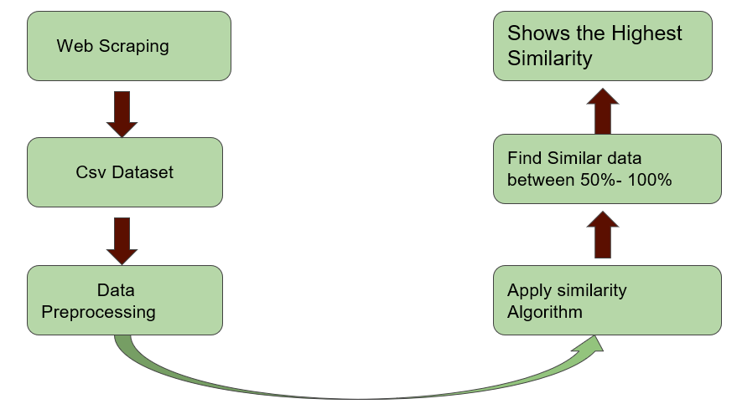

Figure: 1.0 Proposed Model.

In our proposed model we had shown the steps we are following to make the research.

**Web scraping:** Web scraping is the process of using bots to extract content and data from a website. Unlike screen scraping, which only copies pixels displayed onscreen, web scraping extracts underlying HTML code and, with it, data stored in a database. The scraper can then replicate entire website content elsewhere. Web scraping tools are software (i.e., bots) programmed to sift through databases and extract information. We using web scraping for many purpose for example:

* Recognize unique HTML site structures
* Extract and transform content
* Store scraped data
* Extract data from APIs

In our system, we are using web scrapping for exact prices and ratings from different websites so that we can recommend our consumers the best products based on price and ratings.

**CSV database:** A CSV is a comma-separated values file, which allows data to be saved in a tabular format. CSVs look like a garden-variety spreadsheet but with a .csv extension.CSV files can be used with most any spreadsheet program, such as Microsoft Excel or Google Spreadsheets. They differ from other spreadsheet file types because you can only have a single sheet in a file, they can not save cell, column, or row. Also, you cannot not save formulas in this format.

In our system,we are using CSV file for storing products information because

* CSV files are plain-text files, making them easier for the website developer to create
* Since they're plain text, they're easier to import into a spreadsheet or another storage database, regardless of the specific software you're using
* To better organize large amounts of data

**Data** **preprocessing**: As our system collects data from different websites, after web scrapping we will get the different shapes of data. Before applying any algorithm, we need to make all the data in the same structure. For this reason, we apply some natural language processing techniques for preprocessing.

**Cosine Similarity Algorithm:** A commonly used approach to match similar documents is based on counting the maximum number of common words between the documents. Cosine similarity is a metric used to determine how similar the documents are irrespective of their size. Mathematically, it measures the cosine of the angle between two vectors projected in a multi-dimensional space. When plotted on a multi-dimensional space, where each dimension corresponds to a word in the document, the cosine similarity captures the orientation (the angle) of the documents and not the magnitude. If you want the magnitude, compute the Euclidean distance instead.

The cosine similarity is advantageous because even if the two similar documents are far apart by the Euclidean distance because of the size (like, the word ‘cricket’ appeared 50 times in one document and 10 times in another) they could still have a smaller angle between them. Smaller the angle, higher the similarity.

#### Importance of Proposed Research

There is a substantial amount of research occurred in foreign countries as well as in our country. In India there are two notable price comparison tools available such as [www.mysmartprice.com](http://www.mysmartprice.com/) and [www.compareraza.in](http://www.compareraza.in/) [1]. In our country also some price comparison tools and browser Add-ons available such as pricemama.com.bd and bdcost.com. There is a paper also working on the price comparison system in our country that is Upoma – A Dynamic Online Price Comparison Tools for Bangladeshi E-commerce Websites. However, they are not working with the user’s rating system such as our system does.

These things guide us to develop price recommendation tool based on the user’s rating because rating is more important for measuring the product quality. Our System gives direction to the customers to evaluate the price as well as the product quality and make the most manageable purchase decision according to their budget. A considerable amount of work has been deployed earlier. In our country Upoma - A Dynamic Online Price Comparison tools that compare the products price from different websites in 2020. For processing of Bag of words and Vectorization they have used NLP.

They have used the cosine similarity algorithm for Checking the similarity of the products and showed it in a descending manner. Another work was published in 2019. They designed a tool for price comparison which uses scrapping scripts written with a python library and improvised the storage for scrapped data [2]. In 2018, K. Pradeep formulated a pattern analysis recommender system by analyzing buying pattern using data mining technique. In 2016, R. Shah et .al established a website with Django framework and mongo DB for comparing price using web crawling and also used request and BeautifulSoup4 for web scrapping [5].

In this paper we have proposed a price recommendation tools for Bangladeshi websites data. The Goal of this thesis is to investigate the performance if we want to find out the products details according to the user’s query and also help them to find the quality product through this rating system.

We have used web scraping technique for scraping the data from various websites and Fetched data and store to a CSV database. We Vectorize titles and use the cosine similarity algorithm to find the similarity between the search text and dataset text. We have inserted the user’s search data into the csv dataset and then try to find out the similarity between them.

This thesis is divided into five sections: section 2 discusses the literature reviews. Section three explains the materials and method used in the research. The simulation results and their discussions are demonstrated in section 4. Section 5 concludes the thesis with some future direction of this research.

## **Literature Review**

#### Key Concepts, Theories and Studies

Upoma: A dynamic Online Price Comparison tool for Bangladeshi E-Commerce Websites. This system compares different e-commerce websites products and give all the products with price. The paper illustrated a comprehensive price comparison tool based on Bangladesh’s perspective. They have suggested the lowest price for the same product based on the similarity between the user’s query and products stored in the database. They have built a first-ever price comparison tool that can process queries in Bangla language.

Comparison of E-Commerce products using Data Mining. Proposed system uses web scraping technique to extract data from ecommerce web pages and also web crawler to links for products. This help Users in decision making while buying products online. Get the cheapest price of the product with best deal.

E-commerce is the backbone of data mining. Many data mining techniques like association analysis characterization, classification, cluster analysis, and outlier analysis are used for making Ecommerce data more liable.

Mining E-Commerce data from E-Shop websites. Comparing the products price in different e-shop websites. Not functional requirements are they need to keep track of popular and personal choices. Identifying and extracting the product attributes within the products record.

Web Mining Techniques in E-Commerce Applications. Provide E-commerce information/data to the user by using web mining. Provide information of web pages such as Text, HTML, XML, Multimedia and search information. It divides into three parts such as data obtained from consumer’s interaction, data warehouse and data analysis.

#### Significance of Study

The system can process data based on the user’s rating and provide efficient output. The system analyze rating that helps find quality product. Data stored in a single csv file that helps finding product’s effortlessly.

#### Gaps in Existing Knowledge

For all of the above system they are not working with the rating of the products. They only make comparison between price not working with the rating. For that reason may be one can’t find out the actual value of the products. In Upoma: As there is less English alphabet than the Bangla alphabet, indic-transliteration sometimes fails to Romanize the whole query properly. In mining E-Commerce websites Only able to detect the Web pages within a website which contain the product description. No Data storing information and also facing some difficulties in storing data.

#### Recommend products by using cosine similarity

In this paper, They have proposed a robust price comparison tool for Bangladeshi e-commerce websites and for Bangla language. They have used the Scrapy framework to build spiders to crawl through the websites and fetch or scrape information posted on the site [9]. Fetched data is stored in the CSV database. They vectorize titles and use the Cosine Similarity algorithm to find the similarity between the search text and dataset text [10]. They have used the Flask framework for integration between python and website [11]. They have designed User Interface for a user-friendly interaction while searching for query and for showing results appertaining to correspondent query. Some paper used the Web mining technique for finding the ultimate products.

Web data mining became an easy and important platform for retrieval of useful information. Users prefer World Wide Web more to upload and download data. As increasing growth of data over the internet, it is getting difficult and time consuming for discovering informative knowledge and patterns. Digging knowledgeable and user queried information from unstructured and inconsistent data over the web is not an easy task to perform. Different mining techniques are used to fetch relevant information from web (hyperlinks, contents, web usage logs). Web data mining is a sub discipline of data mining which mainly deals with web. Web data mining is divided into three different types: web structure, web content and web usage mining. All these types use different techniques, tools, approaches, algorithms for discover information from huge bulks of data over the web.

## **Research Methodology**

#### Recap of research question

How can customers deal with quality e-products?

* When user’s wants to find out the products then he should search by the products name. whenever the products comes then he finds the products with price not in rating. In our system we can find the quality products by using the rating system of the products.

How can consumers make online shopping less time consuming?

* As the user finds the products with a click and also see the rating so it is easy to find out the quality product and its saves a lot of times.

How ML Algorithms help finding products easily?

* ML makes our daily life easy. We can easily predict something by using ML Algorithms. In this system we store the data in a csv format. All the data remain inside a table. If we wants to find the exact products then we can we can find easily by searching that product by using ML. In our system we use cosine similarity algorithm for similarity checking.

#### Description of Design Method

In this section, we have demonstrated different aspects and the procedure of implementation of our price comparison tool. Algorithm 1 demonstrates the pseudocode for the creation of the database where Algorithm 2 represents the pseudocode for the language processing and comparison methods.

**Algorithm 1 Dataset creation**

1: for each E-commerce site do

2: for each category in the site do

3: for each product in the category do

4: ProductDetails→Link, Name, Price, Rating

5: Use CSS selector to find ProductDetails

6: remove garbage data

7: CSV dataset ← ProductDetails

8: end for

9: end for

10: end for

Dataset is the core element of our price comparison tool. Thus, we have used web crawling approach to collect necessary data from different websites in a fast and efficient way [12]. We have built different spiders for different websites using Python’s powerful Scrapy framework to collect information about products [13]. After that, we store the extracted data in an individual CSV file under the column named “link”, “Product name”, “Product price”, “Products-Rating”, and “Website link” for every website [14]. Once the crawler has completed it traversing through the whole website, it starts to scrape off the correspondents to a particular product discarding superfluous information.

These websites are selected for scraping data based on factors such as diversity of products, popularity and trust, technical support, and scalability. On this note, some of the leading websites have been eliminated such as chaldal.com as Chaldal.com focuses only on grocery items. Another notable website namely bdshop.com cannot be included as the website only provides hardware equipment. We have also ruled out Evaly.com and Daraz.com for being third party platforms for selling products. The spiders are designed in such a way if an e-commerce website authority does remove any category, product or make changes in any products under specific categories, spiders will not be halted and will remain unaffected despite the changes. The aforementioned process is repeated until all websites are traversed, and relevant data is stored. The pseudocode of the method is shown in Algorithm 1. We have collected over 50,000 data by scraping off the websites.

#### Processing and similarity checking

For processing the word we use Count Vectorizer to tokenize the sentence into word. It has been used to depict the significance of word to its corresponding single document in digital libraries.

We have contrived an exact match function from the scratch to extract the precise product what the user has searched for. Exact products are presented in a descending manner. Thus, the product with a lower price ranks first in that order. To find the congruence between user input and the data present in the database, we have constructed the cosine similarity algorithm by using the Sci-kit learn library. Cosine similarity distinguishes between two or more documents on account of the orientation (angle), not the magnitude [17]. The similarity between two documents is calculated by the cosine of the angle of two vectors. Mathematically measurement of cosine angle of the two vectors projected in multidimensional space is considered as distance measurement of two documents. 195 Cosine Similarity focuses on the common words and the occurrence frequency of common words between common words. In addition, Cosine similarity overcomes the flaw of zero matches between two documents irrespective of their sizes. For instance, if a and b are two vectors then cosine similarity uses the following rule:



Where, ⃗a · ⃗b = ∑n 1 aibi = a1b1 + a2b2 + · · · + anbn is the dot product of the two vectors. If the cosine value is 0, then the angle between a and b vector, two vectors are at 90 degrees to each other and share no similarity. Thus, it can be depicted that two vectors are similar when the cosine of the angle of two vectors is smaller.

**Algorithm 2 Product search**

**1**: InSent ← Product to be searched

2: T ← Minimal similarity threshold

9: for each website in our data set do

10: generate bag of words with Count Vectorizer

11: for all products do

12: PN ← product name

13: if PN matches with InSent then

14: put product details in ExactList

15: end if

16: if PN matches with TSent then

17: put product details in ExactList

18: end if

19: if cosine similarity(P N, InSent) >=T then

20: put product details in SimilarList

21: end if

22: if cosine similarity(P N, T Sent) >=T then

23: put product details in SimilarList

24: end if

25: end for

26: end for

27: Sort ExactList according to price in descending order

28: Sort SimilarList according to similarity in descending order and price in ascending order rating in Descending order

On account of cosine similarity, the user can see similar products which are corresponding to their queries. However, there may be too many similar products on different ecommerce websites similar to that of the user’s choice. As the cosine similarity algorithm is performed on every bag (multiset) of words of each website and sorts similar product by their rate of similarity, it can create a long list with repeated or less similar products. Which will certainly increase the difficulty to find the right product from the prolonged list of products. For this reason, we have introduced a variable to control the length of the list, namely, the similarity threshold. The similarity threshold controls how many similar products a user wants to see in the resultant list. It is controlled with a numbered slider bar that dictates the minimum percentage of similarity needed for a product to be able to appear in the result. This value can vary from 50-99 %. We have excluded 100 % match as it is done in a separate algorithm that can detect exact Matched products. Similar results are based upon the query of the user and displayed in an descending manner.

Cosine Similarity and exact match function do find the exact match or similar product contingent to the query. For an instance if user put smartphone in the search bar then he can find out the product details in the screen if the product details are available into the database.

Here is the flowchart of our system

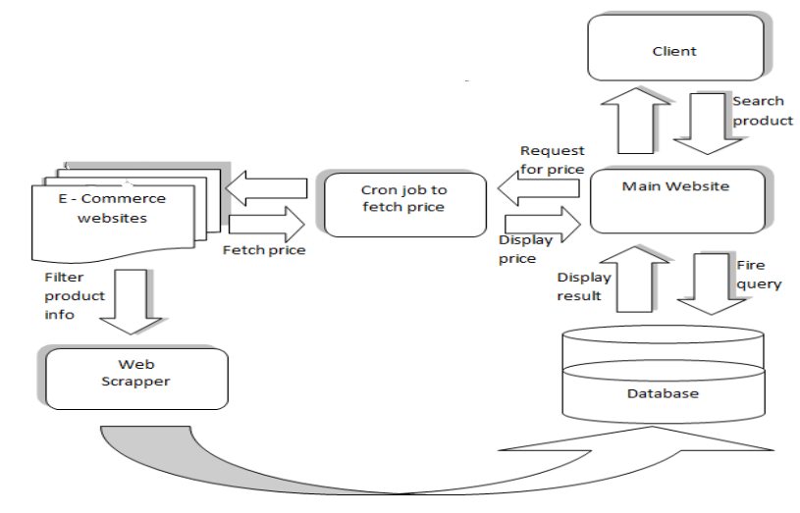

Figure: 3.0 Result Model.

## **Result and Discussion**

In this section, we have thoroughly illustrated the experimental results and performance analysis. The experiment was done Google Colab [18] and in a high-performance server computer with 32GB RAM, and Intel Xenon Processor. Python 3.7 was the core language and we use some libraries from Scikit-learn [19]. Our system shows results according to the user’s query and user-defined threshold.

According to Figure 1, the user’s query text is “smartphone”, and the transliterated query is shown next to it. Our system shows three products found similar to the user’s choice with Image, regular price, offer price, and a corresponding website link. If a user wants to buy a product of his choice, the link given in our site will redirect to the corresponding product page. If there is no difference between regular price and offer price, the result comes with a “name, price and rating” tag beside the product. In this figure, the first table shows the exact product which the user has searched for. The table refers to all of the products that are similar to the user’s search. The 2nd table is displaying the results, which are 50% or higher similar to the user search. Hereby, if a user increases the similarity threshold, there will be less product manifestation in the 2nd table. In the other case, If a user increments the similarity threshold to 99%, the table will not appear with similar products. We have tested our system by putting automated search queries and adjusting the similarity threshold.

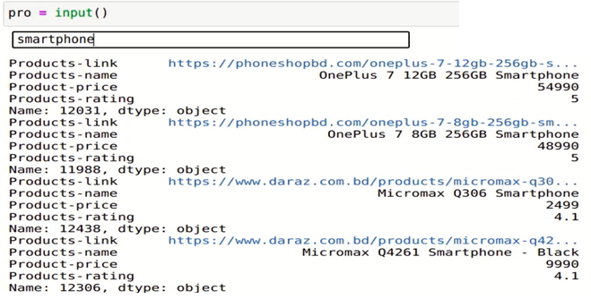

Figure: 4.0 Result Model.

in different values. In every search, we have found at least one exact result matched with the query. We have considered it as an error if the exact product does not appear on the result page despite the availability of that product in the database. After performing 500 queries, we have observed that our system shows the result with 92% of reasonably good accuracy.

## **Conclusion**

The paper illustrated a comprehensive price Recommendation tools based on Bangladesh’s perspective. We have suggested the product for based on the similarity between the user’s query and products stored in the database. We have built a price Recommendation tool based on user’s rating that can process queries. Although we have reached our goal, the system is not beyond limitation. We are not working with in our native language it. For this reason, our next strategy is to develop a transliteration algorithm to conform to our system. In the future, we are planning to arrange a manifestation of consumer reviews and suggest the lowest product based on the good reviews to help consumers to identify the right product to cover their needs according to their budget. Moreover, we will use Neural Networks to generate different predictions and suggestions based on the user’s query.

## **References**

[1] Esther Shaulova and Lodovica Biagi. ecommerce report 2019.

[2] Jawahire Nakash, Shaikh Anas, Siddiqi Muzammil Ahmad, Ansari Mohd. Azam, and Tabrez Khan. Real time product analysis using data mining. International Journal of Advanced Research in Computer Engineering Technology, Mar 2015.

[3] Shakra Mehak, Rabia Zafar, Sharaz Aslam, and Sohail Masood Bhatti. Exploiting filtering approach with web scrapping for smart online shopping penny wise a wise tool for online shopping. In 2019 2nd International Conference on Computing, Mathematics and Engineering Technologies (iCoMET), pages 1–5. IEEE, 2019.

[4] Kali Pradeep, I Bhagyasri, and P Praneetha. E-commerce with backbone of data mining. International Journal of Engineering and Technical Research, 2:460, 10 2018.

[5] Riya Shah, Karishma Pathan, Anand Masurkar, and Shweta Rewatkar. Comparison of e-commerce products using web mining.

[6] Chunmei Zheng, Guomei He, and Zuojie Peng. A study of web information extraction technology based on beautiful soup. JCP, 10(6):381–387, 2015.

[7] Andrea Horch, Holger Kett, and Anette Weisbecker. Mining e-commerce data from e-shop websites. In 2015 IEEE Trustcom/BigDataSE/ISPA, volume 2, pages 153–160. IEEE, 2015. [8] Ying Ming-Hsiung and Hsu Yeh-Yen. A commodity search system for online shopping based on ontology and web mining. In IET Conference Proceedings. The Institution of Engineering & Technology, 2014.

[9] Ahmad Tasnim Siddiqui and Sultan Aljahdali. Web mining techniques in e-commerce applications. arXiv preprint arXiv:1311.7388, 2013.

[10] Dwijen Rudrapal, Amitava Das, and Baby Bhattacharya. Measuring semantic similarity for bengali tweets using wordnet. In Proceedings of the International Conference Recent Advances in Natural Language Processing, pages 537–544, 2015.

[11] Fankar Armash Aslam, Hawa Nabeel Mohammed, Jummal Musab Mohd, Murade Aaraf Gulamgaus, and PS Lok. Efficient way of web development using python and flask. International Journal of Advanced Research in Computer Science, 6(2), 2015.

[12] Eloisa Vargiu and Mirko Urru. Exploiting web scraping in a collaborative filtering-based approach to web advertising. Artif. Intell. Research, 2(1):44–54, 2013.

[13] Amna Shifia Nisafani, Rully Agus Hendrawan, and Arif Wibisono. Eliciting data from website using scrapy: An example. SEMNASTEKNOMEDIA ONLINE, 5(1):2–1, 2017.

[14] Joydeep Bhattacharjee. Working with data. In Practical Machine Learning with Rust, pages 141–186. Springer, 2020.

[15] N. UzZaman and M. Khan. A double metaphone encoding for bangla and its application in spelling checker. In 2005 International Conference on Natural Language Processing and Knowledge Engineering, pages 705–710, Oct 2005.

[16] Joeran Beel, Stefan Langer, Marcel Genzmehr, Bela Gipp, Corinna Breitinger, and Andreas Nürnberger. Research paper recommender system evaluation: a quantitative literature survey. In Proceedings of the International Workshop on Reproducibility and Replication in Recommender Systems Evaluation, pages 15–22, 2013.

[17] Jun Ye. Cosine similarity measures for intuitionistic fuzzy sets and their applications. Mathematical and computer modelling, 53(1-2):91– 97, 2011.

[18] Tiago Pessoa, Raul Medeiros, Thiago Nepomuceno, Gui-Bin Bian, V.H.C. Albuquerque, and Pedro Pedrosa Filho. Performance analysis of google colaboratory as a tool for accelerating deep learning applications. IEEE Access, PP:1–1, 10 2018.

[19] Fabian Pedregosa, Gaël Varoquaux, Alexandre Gramfort, Vincent Michel, Bertrand Thirion, Olivier Grisel, Mathieu Blondel, Peter Prettenhofer, Ron Weiss, Vincent Dubourg, et al. Scikit-learn: Machine learning in python. Journal of machine learning research, 12(Oct):2825–2830, 2011.